**Idea 1 – Gingerbread man**

Setting: in the forest (trees, bushes, hills, mountains, lake, etc…)

Start: gingerbread man walking down a forest path, with small creatures trying to eat him

Weapon: soft candy drops that he spits out

-candy drops expands and covers the creature, gingerbread man touches candy -> POINTS

-numbers of points depend on catching difficulty (fast and flying vs. slow and crawling)

Objective: get to the lake and onto a boat to row across the lake to the other level before the big bad wolf comes to eat the gingerbread man

-candy drops can’t kill the wolf, only slow him down

-collect as many points as you can before the wolf comes

Gameplay:

* Arrow keys to move the gingerbread man
* Small creatures will appear in front and wolf can be hiding in the bushes
* Gingerbread man can walk, run, jump, climb, hide
* Press shift and can see whole game view to see where the wolf is and think of tactics to get to the lake before getting caught

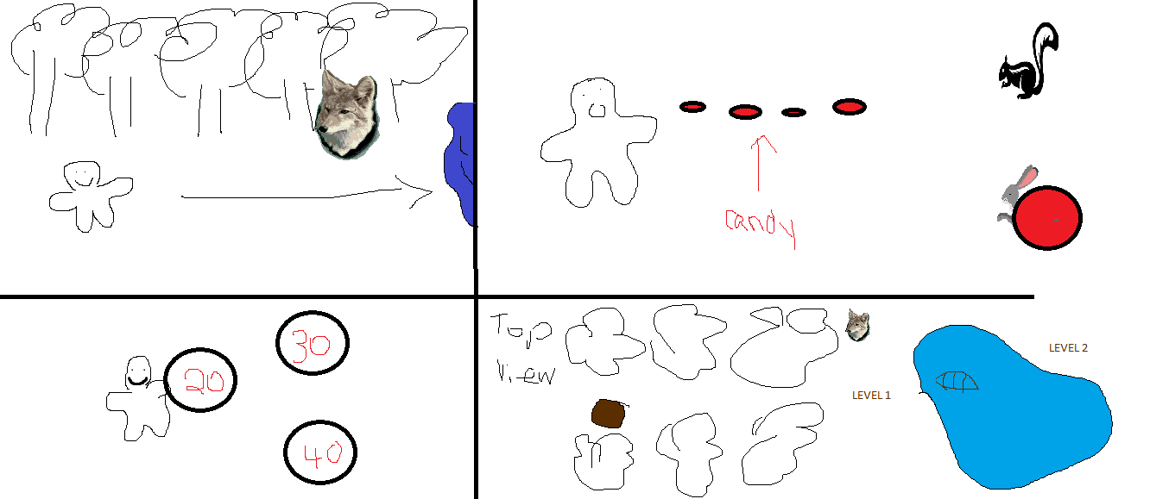

**Idea 2 – Penguin waddle**

Setting: arctic pole setting (ice sheets, snow hills, lots of snow…)

Start: penguin walking along the snowy path with snowman throwing snowballs at him

Weapon/defence: penguin can slide on his stomach and knock the snowmen down -> they break up into snowballs parts which you can collect as points

-can swim the water to get fish to gain life or points depending on fish

Objective: knock over as many snowmen and collect their snowballs for points

-get fish in the water to gain life and points

-need to find the igloos to move onto the next level without getting hit by too many snowballs and dying

Gameplay:

-arrow keys to move the penguin

-snowmen and snowballs will be thrown from the front need to attack (think of bowling ball hit bowling pins)

-too many snowmen? Go to nearest lake to hide in water

